Install Tomcat and start the tomcat and deploy a war file

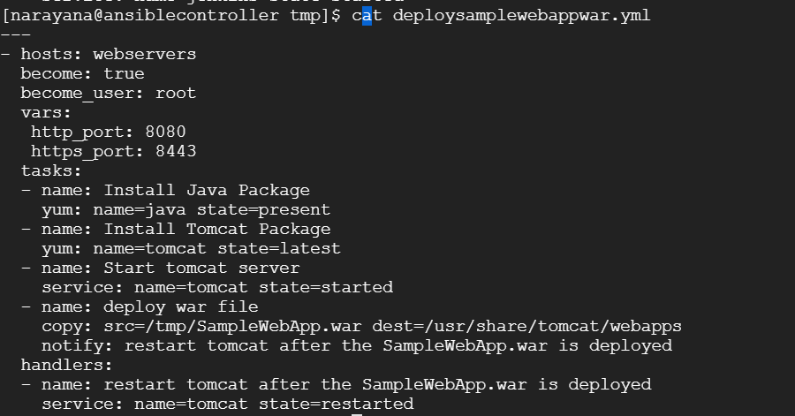

---

- hosts: webservers

become: true

become_user: root

vars:

http_port: 8080

https_port: 8443

tasks:

- name: Install Java Package

yum: name=java state=present

- name: Install Tomcat Package

yum: name=tomcat state=latest

- name: Start tomcat server

service: name=tomcat state=started

- name: deploy war file

copy: src=/tmp/SampleWebApp.war dest=/usr/share/tomcat/webapps

notify: restart tomcat after the SampleWebApp.war is deployed

handlers:

- name: restart tomcat after the SampleWebApp.war is deployed

service: name=tomcat state=restarted